BRAEMAR MOUNTAIN RESCUE TEAM
STANDARD OPERATING PROCEDURE FOR PETZL I'D

Introduction
The Petzl I'D is a self-braking descender which can also be attached to a fixed anchor and used to lower heavy loads.
The purpose of this Standard Operating Procedure (SOP) is to describe how the I'D should be used as part of the twin rope system favoured by Braemar Mountain Rescue Team. This SOP is based on the technical specifications and operational guidance issued by Petzl. It also draws on the team's experience from using the I'D since 2002.
It is intended that the guidance herein will be followed when the I'D is used and by having a standard method of use team members will become familiar with that approach and rope rescue operations will run smoothly and safety will be enhanced.
While this SOP describes a standard approach for using the I'D during lowers, it is recognised that the device is versatile and has other uses. It is the responsibility of the appointed Operation Manager at the scene, along with the Incident Safety Officer, to agree safe alternative use of the I'D, having given due regard to the technical information provided by Petzl.
SAFE WORKING LOAD
The gold coloured I'D (S) used by the team are designed for use with ropes from 10mm to 11.5mm and are therefore suitable for use with our 10.5mm low stretch rescue lines.
The I'D (S) is stamped with having a safe working load of 150kgs but Petzl's technical information describes how the I'D (S) can be rigged to safely lower loads up to 250kgs.
Petzl highlights three techniques to improve control of braking when the I'D (S) is on a fixed anchor and lowering weights between 150kg - 250kg:
- Use a rope of 10.5mm or greater
- Two-person operation, with addition of a brakeman
- Munter hitch on the braking carabiner
The guidance allows that too much friction can be a handicap and Petzl recommends use of only two of the aforementioned braking improvement techniques at any given time, with all three only being necessary in extreme situations.
To increase levels of safety the rescue team's procedures incorporates both the first two recommendations and includes the third, but without use of the Munter hitch, ie rope is simply routed through the additional braking carabiner. The team also uses two ropes, with each rope having a separate I'D, configured in the enhanced braking arrangement described above.
To ensure that the safe working load is not exceed it is imperative that both rescue ropes are kept taunt to avoid risk of shock-loading the component parts of the system when a weight comes on to slack ropes.
Team members must practice regularly with the device to ensure they reach and maintain the technical competence required to safely use the I'D in both training and rescue scenarios.
ID Parts
The accompanying photograph (fig 1) shows the I'D with the main parts named.
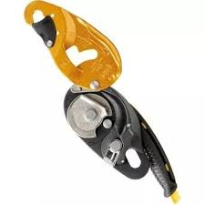
- Moving side plate
- Cam
6
- Anti-error catch
1
- Fixed side plate
- Handle
- Safety gate
2
- Handle button
4
7
5
3

As with all rescue kit, ensure device is free from cracks, deformity and corrosion before use. Check the cam is not worn and that the swinging side plate is not twisted and locates properly on the head of the cam axle when closed. Check all moving parts for wear and functionality.
Belay/Anchor
The team favours the use of a three-point anchor 'spider' belay (fig 2) with a separate 'spider' set up for each of the two rescue lines. It is best to slightly offset the position of the 'spider' knots, with one belay stance being slightly forward of the other, to allow extra space for the rescue belayers to work. Low stretch ropes are used to construct the 'spider' to avoid the 'see-sawing' effect which can result from use of dynamic climbing ropes.
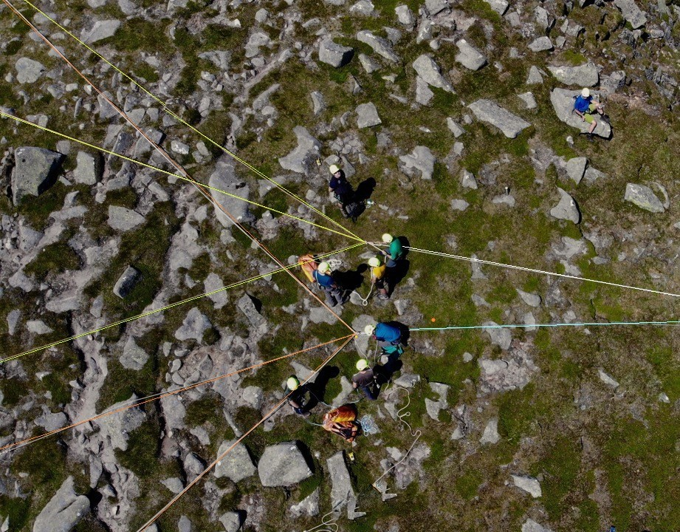
Tests have shown that attaching both I'Ds to one multi point anchor (Bear Paw or similar belay plate) frustrates smooth lowering due to twisting of the belay plate causing the I'D to repeatedly auto-lock. Having the I'D on separate anchors eliminates this problem.
(fig 2)

Attaching I'D and Installing Rope
Inspection before Use
Warning, if the I'D is held horizontal by the hand the braking function can be rendered inoperative. Ie. Rope can lie slack around the friction cam and could run freely.
The I'D works best when the device is orientated vertical to the ground. ie. held so that when the release handle is moved to the unlocked position the handle is pointing up. This ensures the rope lies properly against the friction cam. To achieve this, attach the I'D by a locking carabiner to the belay knot and orientate the device into vertical plain. (fig 3). The belay knot on 'spider' can be an overhand knot or a figure of eight knot with the latter being easier to release after heavy loading.
To load the rescue rope, open the moving side plate and move the brake handle to ensure maximum clearance between the cam and the fixed pillar. The diagram stamped on the device clearly shows how the rope should look when rigged properly. Close the side plate and ensure it has closed properly and that the safety gate has ‘clicked’ onto the carabiner.
Before use and before anyone ties into the system ensure the rope is correctly installed. Keep hold of the braking side of the rope and gently pull on the load/active side of the rope to confirm that the auto-lock engages. If the rope has been installed wrongly the toothed anti-error catch will engage when the brake end of the rope is pulled back towards the belay.
Having installed the rope properly it is important that the brake end of the rope is routed through a locking carabiner which has been attached to the knot of the 'spider'. (fig 3).
This whole arrangement is replicated for the second rescue line and the rescuer about to be lowered can then tie into both rescue lines.
The Safety Officer will check the entire system before the lower commences.
The belayer, wearing suitable gloves, should face towards the belay and take control of the brake handle in one hand whilst the other hand takes control of the braking end of the rope.
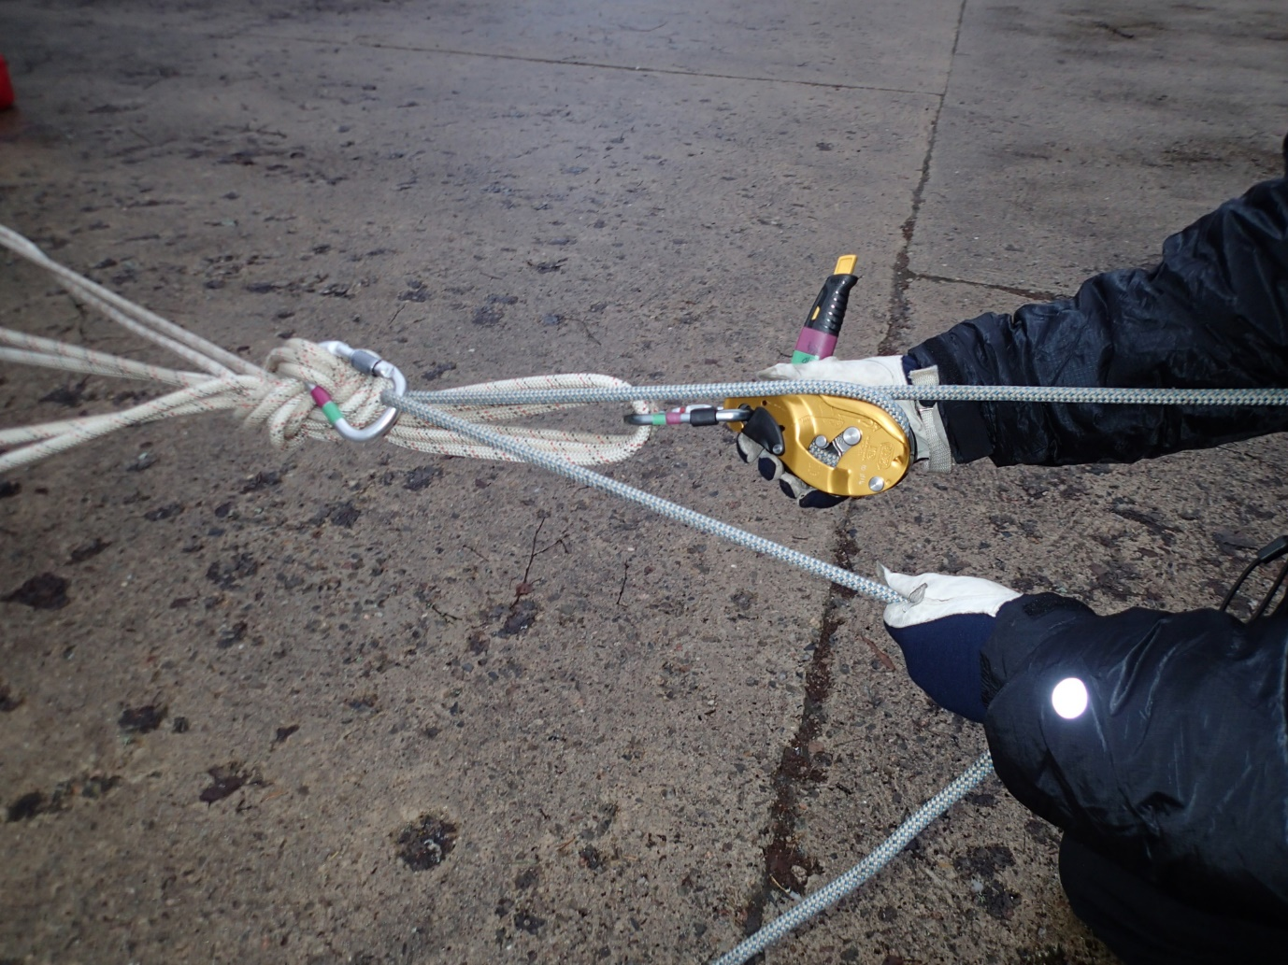
(fig 3)

The I'D handle has three positions- the first is all the way down with the inside edge of the handle close to the edge of the I'D base plate. This is the 'hard lock’ position. In order to begin lowering the handle is rotated about 250 degrees to where the handle begins to disengage the friction cam from the rope. Further gentle rotation of the handle a few degrees more will allow the rope to feed out. If the handle is pushed beyond this second, lowering position, the device will lock out, in its soft lock position. This auto-lock either side of the small arc where handle allows the rope to move is the panic lock feature of the device.
With the release handle held in the lowering position the speed of decent is controlled by the hand holding the braking end of the rope allowing the rope to slip through.
If the device locks up, the handle has to be brought back past the audible ratchet click before being moved forward again into the lowering position.
A second belayer is located alongside the main belayer and their role is twofold; in addition to ensuring the rope pays out without any tangles they must also hold the rope and be ready to act as a second brakeman if required.
Although the I'D is very simple to use it is only through regular practice that smooth and safe lowers can be achieved using a pair of I'Ds on a twin rope system.
When the rescuer is moving over a horizontal step the tension is often reduced on the rescue line and the auto-lock on the I'D can activate as different tensions are applied to the rope. With practice this can be smoothed out and the tendency to ‘lock out’ reduces as more line is paid out and sudden tension changes being transmitted all the way back to the I'D are reduced.
Petzl state that with handle engaged in the 'hard lock' position no further tie off is required. Team procedures however dictate that if there is someone attached to the ropes the I'D will only be unattended if the 'hard lock' is engaged and the brake side of the rope is tied off to one of the carabiners attached to the 'spider' belay
I'D within a Pulley System
If during a lower there is a requirement to raise the rescue load this can quickly and safely be achieved without having to remove the ropes from the belay devices.
The improvised pulley can be fitted to one rope and while this is being set up the second rope and belay device should be hard locked and tied off.
A Petzl shunt, with a carabiner and rescue pulley attached, is fitted as far down the pulling rope as safely possible. Without opening the I'D, take the rope out of the additional brake carabiner and thread a loop of rope through the rescue pulley. The pulling end of the rope is then led back towards the I'D, so persons pulling the rope will end up pulling away from the cliff edge. (See fig 4).The second rescue rope is then rigged with an identical pulley arrangement.
This simple rigging gives an approximate 2:1 pulling advantage and both ropes should be pulled in smoothly, without jerking. Although it is possible to have a pulley attached to a single rope, whilst the slack in the second rope is simultaneously taken in through the I'D, in practice this single pulley arrangement exerts more strain on one rope and requires more effort from those doing the hauling.
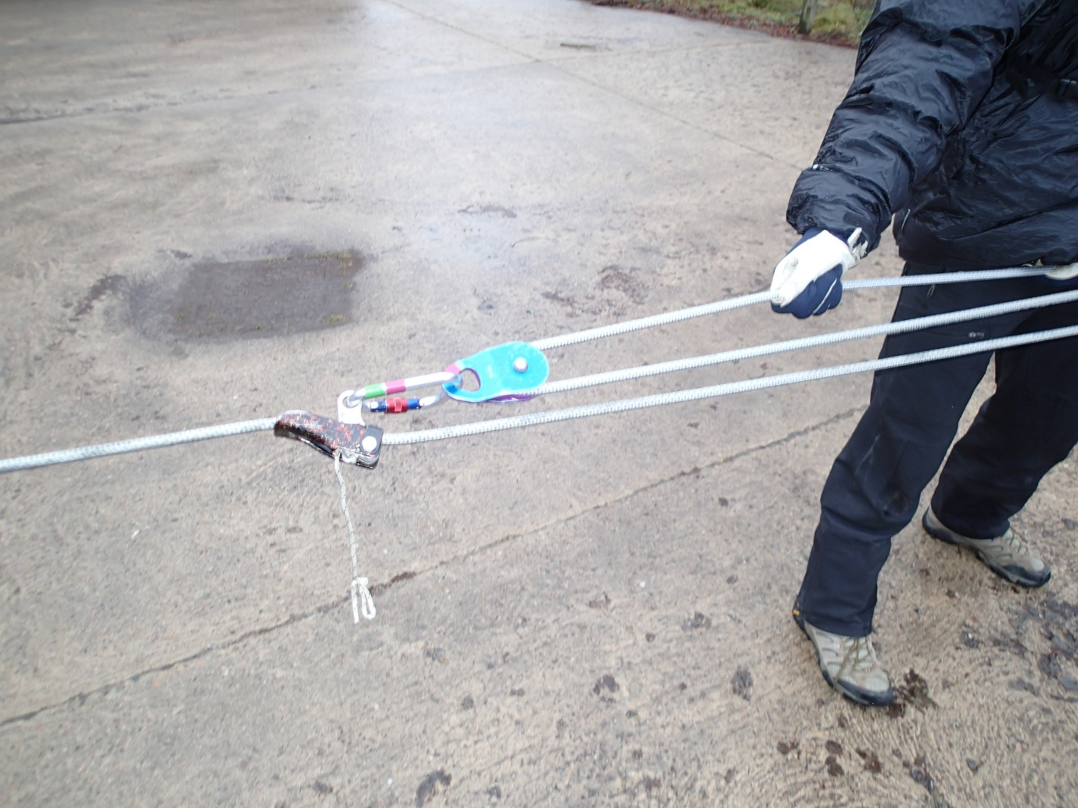
(fig 4)
Any rope gripping device can be used in place of the Shunt, but toothed cam devices should normally be avoided to prevent damage to the rope. Consideration could be given to using a toothed camming device where ropes are iced and shunt is failing to grip. A Prusik knot is a safe alternative but is not so easy to reposition after each pull. The shunt is considered most suitable because it will slip, without causing damage to the rescue rope, if excessive loads, in region of 3kN, are generated. This in effect acts as a ‘safety valve’ against rescuers exerting too much strain on the rescue line. If too much pulling effort is having to be exerted it is likely that the load or rope has become stuck and the reason for the excess effort should be investigated and fixed rather than adding additional people to the pulling effort.
As with the lowering operation, to ensure that the safe working load is not exceeded it is imperative that shock-loading is avoided and that no slack is allowed on either rope.
If during a lower the weight has come off the rescue ropes for a period, eg when rescuer arrives at casualty and, should weight going on to the rescue line increase, ie casualty and stretcher added to the load being lowered, it is important that both ropes be tensioned from above to take out any rope stretch/slack which could cause the rescue load to drop a short distance before the strain is caught. It simple terms the ropes should be tensioned before any interrupted lower resumes.

June 2018.
Disclaimer
The technical specifications and operational guidance detailed above have been calculated and recommended by others so Braemar Mountain Rescue Team cannot vouch for their accuracy nor guarantee correctness or fitness for use.

